Peaches and Cream Oatmeal

Servings: 1 Prep Time: 5 Minutes Cook Time: 5 Minutes Total Time: 10 Minutes

Ingredients

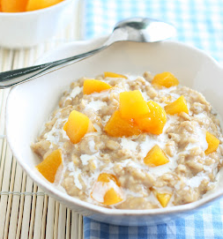
- 1/2 cup milk
- 1/2 cup old fashioned oats
- 1/2 cup water
- 1 Tbsp packed light brown sugar or granulated sugar
- 1/8 tsp cinnamon (optional)
- 1 dash salt
- 1/4 tsp vanilla
- 1/2 cup canned peaches drained or fresh peaches, diced
- 2 Tbsp cream or half-n-half

Instructions
- In a large microwave safe bowl, combine oats, milk, water, sugar, optional cinnamon and salt. If using fresh peaches add them to oatmeal mixture before microwaving so they will cook and become softened.
- Microwave mixture on HIGH power for 3 1/2 - 4 minutes. Remove from microwave and stir in vanilla. If using canned peaches fold them into oatmeal after microwaving. Drizzle oatmeal with cream. Serve warm.

Recipe Notes
- *Quick oats will work too just reduce cook time by about 1 - 1 1/2 minutes.

