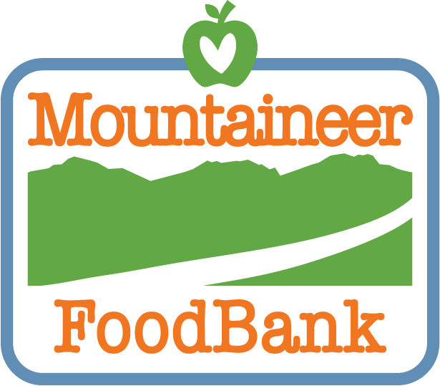
YEAR(S): ________________

Food Distribution Program
Temperature Log

Please record your temperatures at least once every 72 hours

Acceptable Temperatures:

Dry Storage Areas: 50°F - 70°F Coolers: 35°F - 41°F Freezers: -10°F - 0°F

The person(s) responsible for this log should place their initials above the temperature each time it is recorded.
 | July | Aug | Sept | Oct | Nov | Dec | Jan | Feb | Mar | Apr | May | June
1
2
3
4
5
6
7
8
9
10
11
12
13
14
15
16
17
18
19
20
21
22
23
24
25
26
27
28
29
30
31

West Virginia Department of Agriculture

