How to Order from Mountaineer Food Bank

Step 1
www.mountaineerfoodbank.org

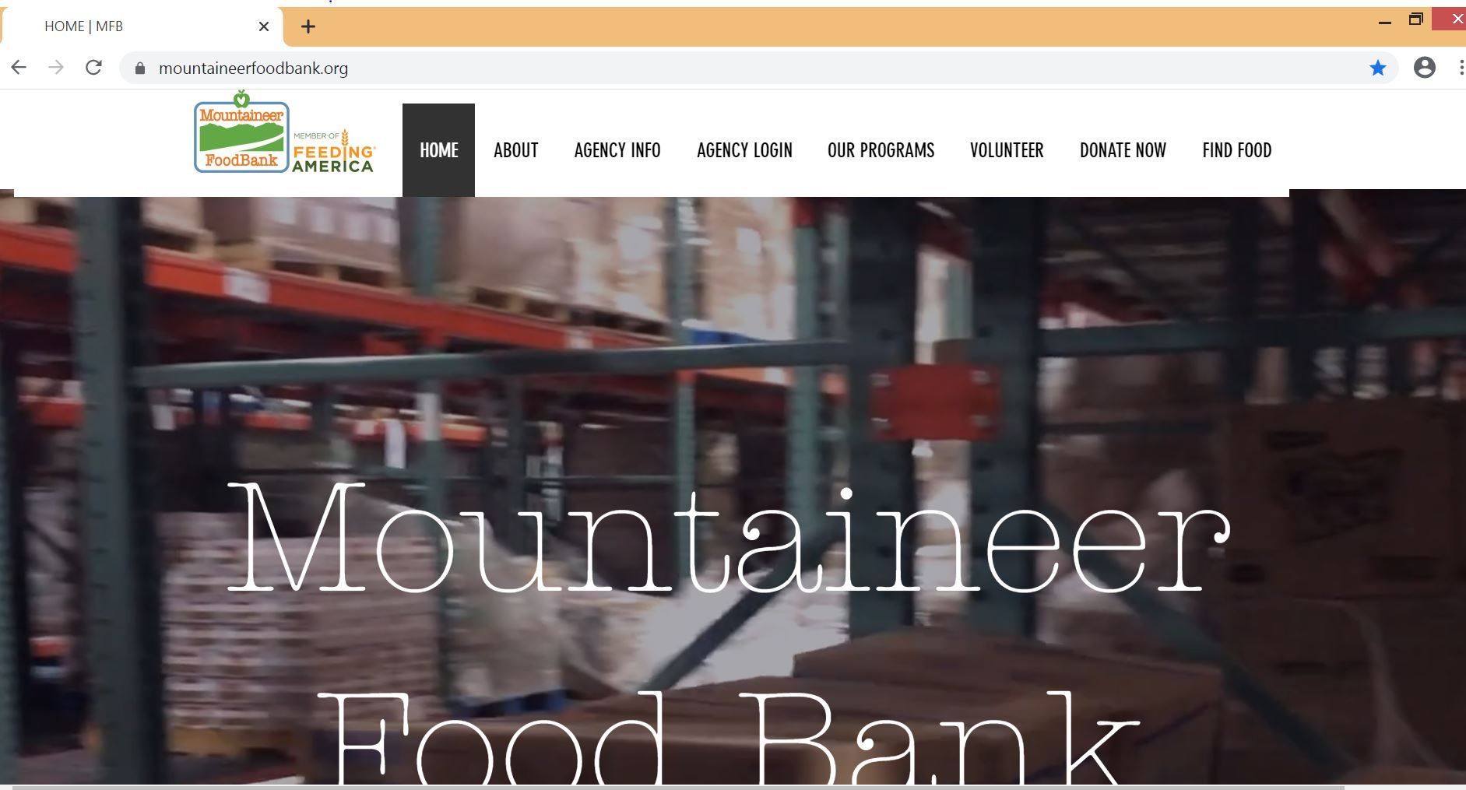

Step 2
Click Agency Login

Step 3
Enter your Information and click Login
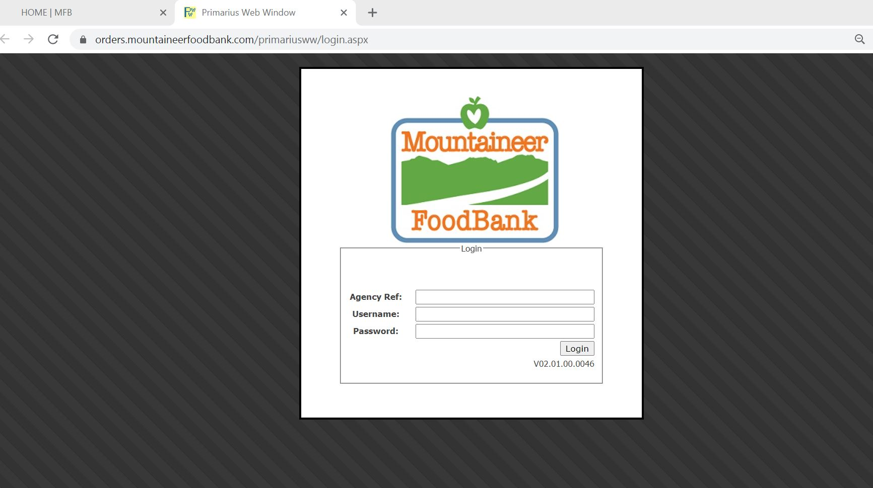

Step 4
Review the Home Tab
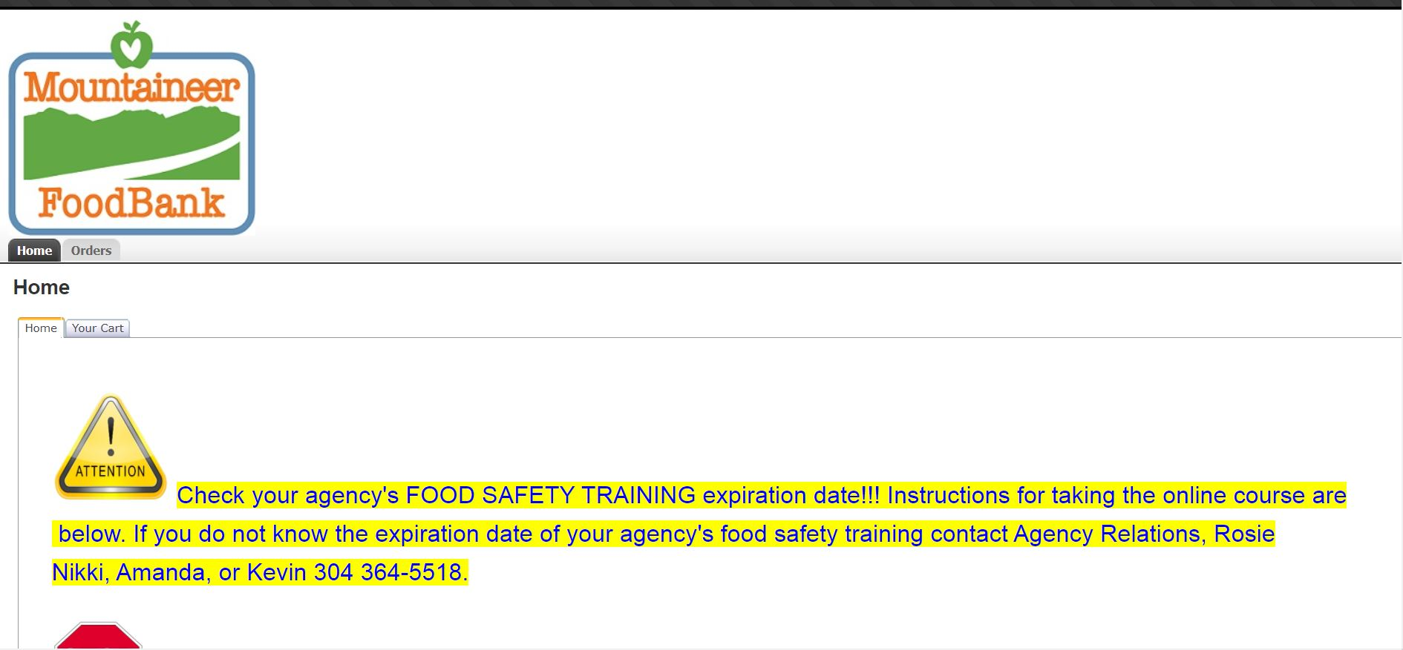
View past and current orders on the orders tab.
Always check the home page for urgent notifications.

Step 5
Scroll to the right hand side of the page to place an order.
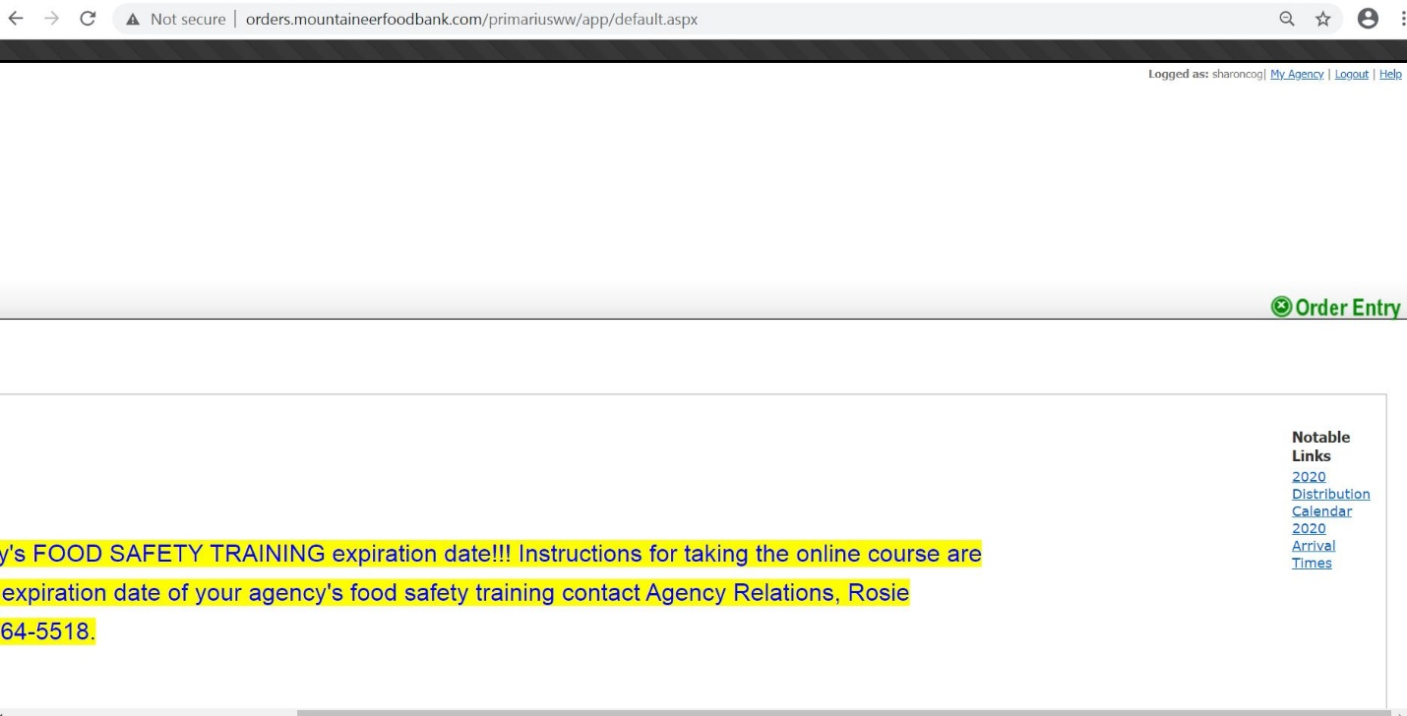
The annual delivery calendars are posted here.
To place an order click Order Entry
Depending on screen and font size, you may have to scroll to the right of the homepage to find your “Order Entry” button.

Step 6
Complete Order Delivery Method & Click Continue
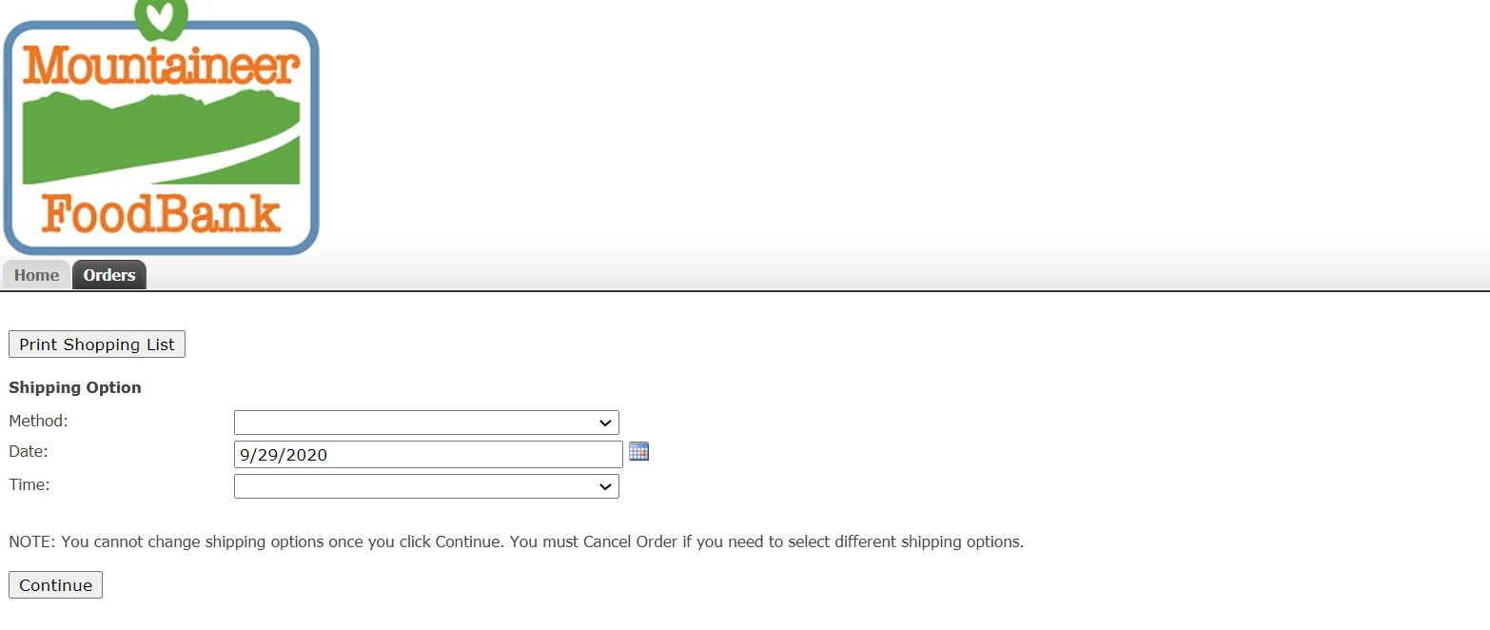
If Method is Delivery - the date selected MUST match the date MFB’s delivery truck is scheduled for your county. For the calendar, please see “Notable Links” & select “Distribution Calendar”
Method
Pickup – Order to be picked up at Mountaineer Food Bank’s warehouse in Gassaway. Please call MFB’s inventory clerk at:(304)364-5525 to schedule an appointment.
Delivery – Order is to be delivered at the central distribution site within the county. To get your county’s distribution location please go back to the homepage & scroll over to “Notable Links” & select “Arrival Times.”

Select 7:00-7:05, this is random, but your only option. Please see your delivery arrival times on the “Notable Links”

Step 7
Access the Inventory Page
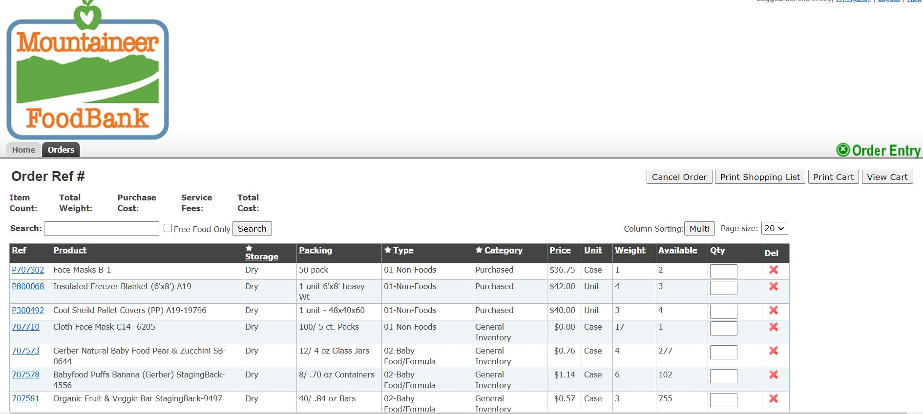
Search for specific items here!
Check box and hit search for Free Product!
Enter in the quantity you would like to receive. After entering the quantity if you decide you don’t want the product please hit the Red “X”.

Step 8
Understanding Product Categories
Categories
Weight
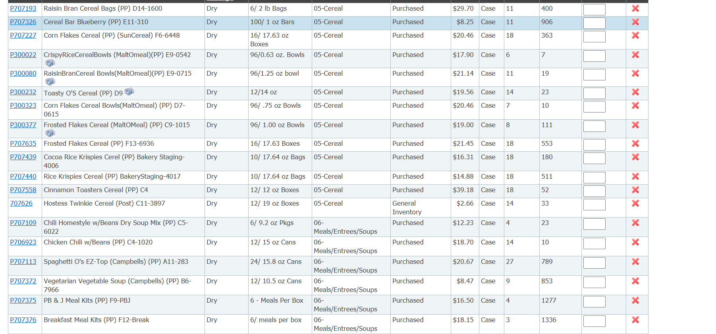
Click the Camera Icon for a picture of the product.
Fees
Product Category | Service Cost | Transportation Cost
General Inventory | $0.19 per pound | $0.08 per pound
USDA | $0.00 | $0.00
Dairy, Bakery, Produce | $0.10 per pound | $0.00
Purchase Program | As Stated | $0.00
Occasionally MFB has products available at no charge. There is no transportation fee added to these items.

Step 9
Checking Out

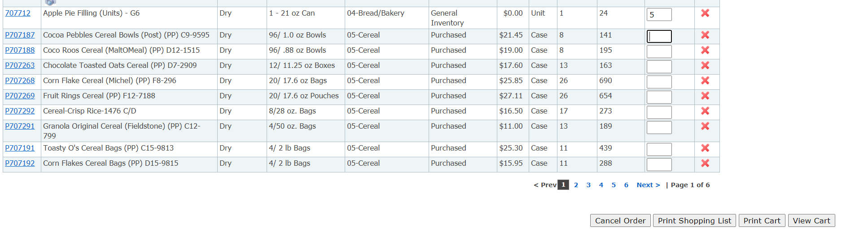
To Check Out – select “View Cart”

To Cancel Order – select “Cancel Order”

To print the page you are on (all items listed) – select “Print Shopping List”

To print your shopping cart (the items you are ordering) – select “Print Cart”

If you do not check out your order will automatically be cancelled in 8 hours.

Step 10
Complete Order

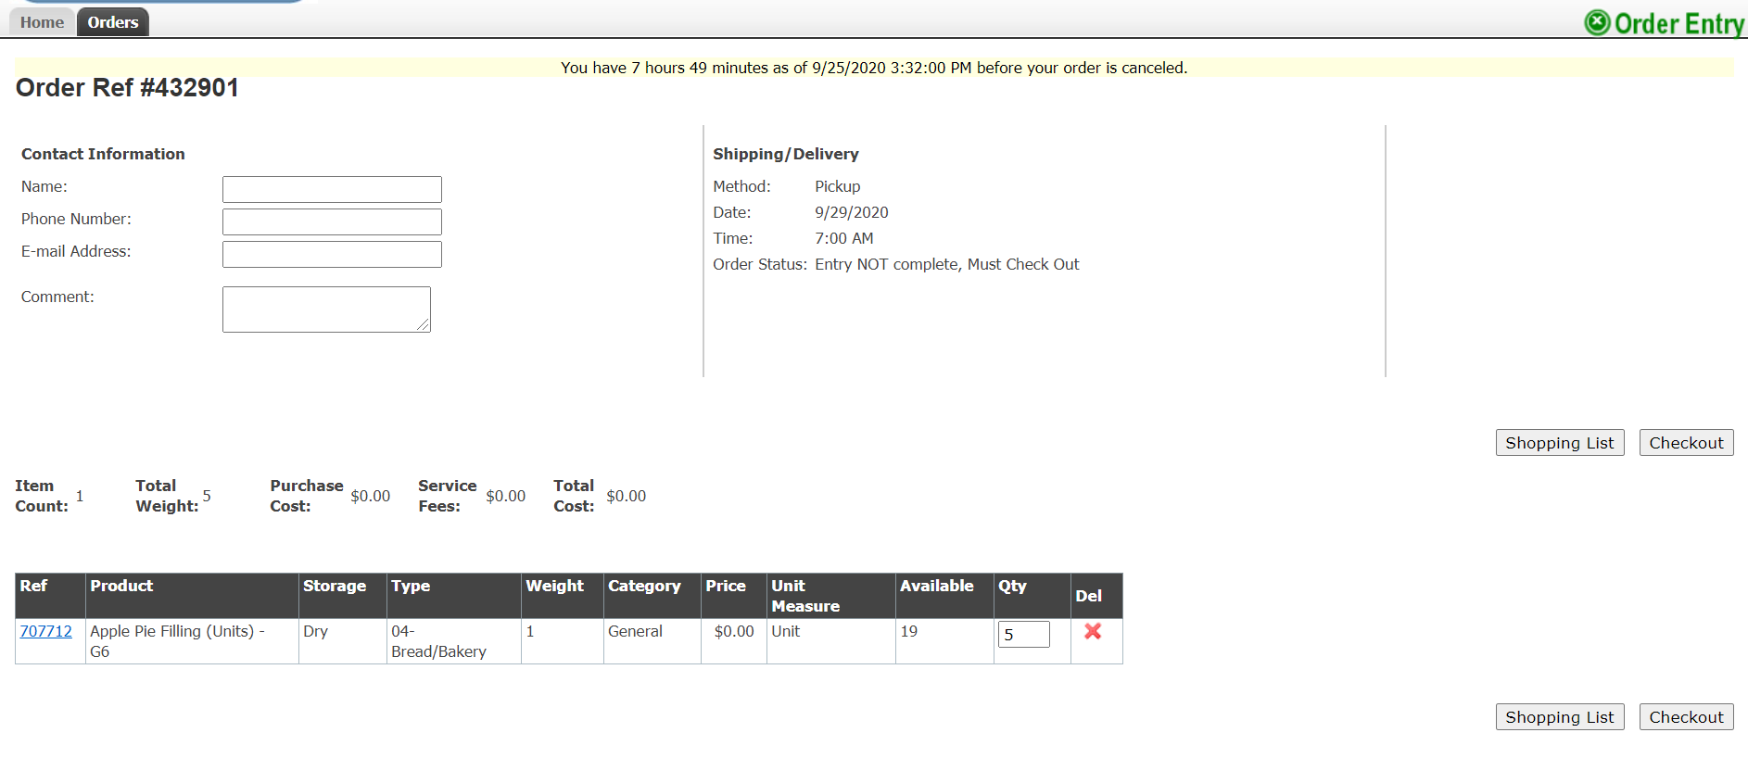
Enter in your contact information.
Confirm your delivery date matches the MFB Delivery Calendar for your county.
Confirm your product order.
Manually calculate your transportation and service costs so you know what to expect when MFB gives you the receipt of invoice. Any agencies picking up at Mountaineer Food Bank will not be charged a transportation fee.

If there is a product that you do not want in the cart anymore hit the red “X”.
If you want to cancel your order please close out and it will cancel itself automatically in 8 hours.
If everything is correct and you want to continue, please select “Check Out”

If you have any problems please contact our Inventory Clerk at (304)364-5525.

Step 11
Finished

Congratulations! Your Order is completed! Please select the pdf file and bring it with you to pick up your order. Please keep a copy of your order confirmation and invoice for at least 4 years.
Mountaineer Food Bank will provide you with a receipt of invoice.
Please use the receipt of invoice to make a payment to Mountaineer Food Bank within 14 days.
Please mail the payment to:
Mountaineer Food Bank
484 Enterprise Drive
Gassaway, WV 26624

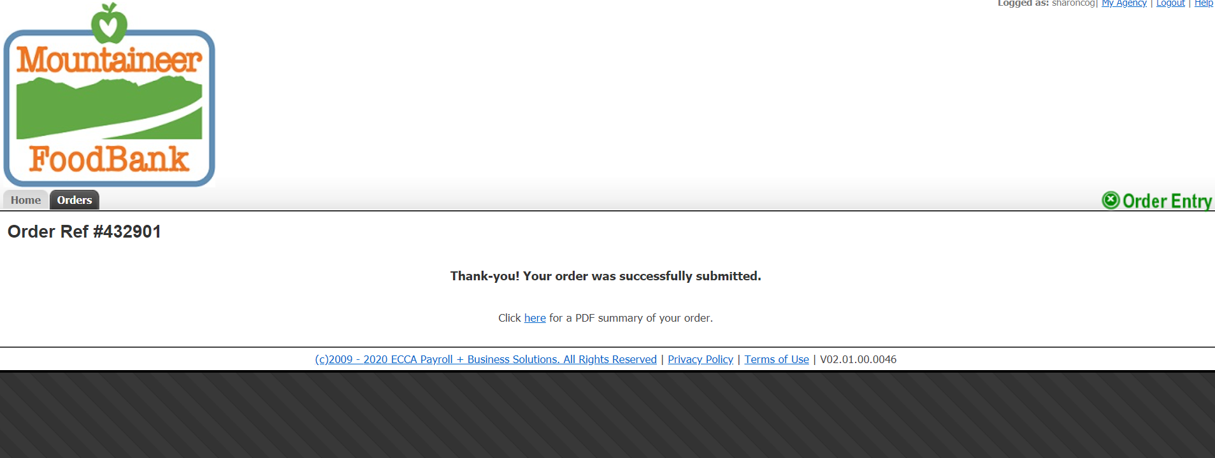

Please remember orders must be placed a minimum of 2 ½ MFB business days by 1:00 PM prior to the delivery or pickup date. All changes made to orders after 1:00 PM, 2 ½ MFB business days before delivery or pickup OR any agency who does not pickup their order will be charged a $20.00 restocking fee.

